|  |  |
| --- | --- |
| **Nastavni predmet:** | **MIKROUPRAVLJAČI** |
| **Vježba br.14:** | **Servo Motor** |
| **Cilj vježbe**: | **Naučiti programirati IC senzore** |

**Zadatak 1:**Spoji prema zadanoj shemi i napiši program će upaliti LED diodu kada se pritisne gumb na daljinskom.

**Grafički prikaz:**

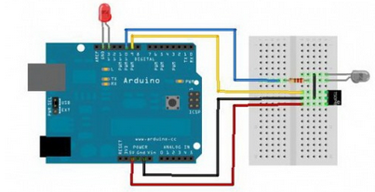

**Kod zadatka:**

//definiramo pinove

#define IRsensorPin 9

#define IRledPin 10

#define D13ledPin 13

void IR38Write() { //pišemo kod funkcije „IR38Write“

for(int i = 0; i <= 384; i++) {

digitalWrite(IRledPin, HIGH);

delayMicroseconds(13);

digitalWrite(IRledPin, LOW);

delayMicroseconds(13);

}

}

void setup(){ //određujemo pinove

pinMode(IRledPin, OUTPUT);

digitalWrite(IRledPin, LOW);

pinMode(D13ledPin, OUTPUT);

digitalWrite(D13ledPin, LOW);

}

void loop(){

IR38Write();

if (digitalRead(IRsensorPin)==LOW){

digitalWrite(D13ledPin, HIGH);

}

else {

digitalWrite(D13ledPin, LOW);

}

delay(100);

}

**Zadatak 2:**Spoji Servo motor prema zadanoj shemi i napiši program pomoću kojeg se pokreće Servo motor pomoću daljinskog.

**Grafički prikaz:**

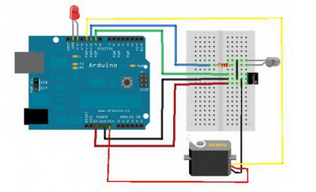

**Kod zadatka:**

#include <Servo.h>

#define IRsensorPin 9

#define IRledPin 10

#define ServoPin 11

#define D13ledPin 13

#define Front 90

#define LeftSide 0

#define RightSide 180

byte ObjectDetected=0;

Servo PanServo;

void IR38Write() {

for(int i = 0; i <= 384; i++) {

digitalWrite(IRledPin, HIGH);

delayMicroseconds(13);

digitalWrite(IRledPin, LOW);

delayMicroseconds(13);

}

}

void setup(){

pinMode(IRledPin, OUTPUT);

digitalWrite(IRledPin, LOW);

PanServo.attach(ServoPin);

PanServo.write(Front);

pinMode(D13ledPin, OUTPUT);

digitalWrite(D13ledPin, LOW);

}

void loop(){

ObjectDetected=0;

IR38Write();

if (digitalRead(IRsensorPin)==LOW){

PanServo.write(LeftSide);

delay(100);

IR38Write();

if (digitalRead(IRsensorPin)==LOW){

ObjectDetected=1;

}

PanServo.write(RightSide);

delay(200);

IR38Write();

if (digitalRead(IRsensorPin)==LOW){

ObjectDetected=2;

}

}

switch (ObjectDetected){

case 1:

break;

case 2:

break;

}

PanServo.write(Front);

delay(100);

}